**Part 1A**

Mr. Phillips is a small business owner who owns a barbershop called “Phillip’s Barbershop”. The barbershop contains three (3) stations for cutting hair which he sub-contracts to three (3) barbers. Customers are required to give the following information when requesting a service:

* customer name
* service needed
* station number

Mr. Phillips collects 5% of the daily sales amount plus a fixed amount of $500.00 (per day) from each station as rent. He wants a digital system to help manage his daily operations so he can closely monitor the revenue generated from the Barbershop.

The barbershop opens at 9:00 AM each day.

Assume that each station takes a total of 30 minutes to complete a customer’s requested service and all appointments are kept, design a simulation of Mr. Phillip’s Barbershop that accepts the above stated information as input and continues accepting inputs until the total minutes of 720 or exactly 9:00 PM is reached.

The table below shows the services Phillip’s Barber Shop offers:

**Updated IPO Chart**

| Input | Process | Output |
| --- | --- | --- |
| snum  Lname  Fname  service | Control Structure:   * For loop - For (minutes = 0, minutes <= 720) * Validation Checks-   + Pretest While statement: Fname and Lname are at least 3 char long.   + Pretest While Statement - Service not in [ “M”, “S”, “C”, “G”, “B”, “E”]     - Nested CASE STRUCTURE: service = M, S, C, G, B or E   + Pretest While Statement- snum < 1 or snum > 3 * CASE Structure: snum = 1, 2, or 3 * Nested IF Statement: To display service selected.   Calculation:  CASE- Total sales and customers per station:   * tot_station1 = tot_station1 + price * cNum1 = cNum1+ 1 * tot_station2 = tot_station2 + price * cNum2 = cNum2 + 1 * tot_station3 = tot_station3 + price * cNum3 = cNum3 + 1   Commission per station for the day:   * commision1 = tot_station1 - (0.05 * tot_station1 + 500) * commision2 = tot_station2 - (0.05 * tot_station2 + 500) * commision3 = tot_station3 - (0.05 * tot_station3 + 500)   Total Sales & customers for the day:   * statEarn = tot_station1 + tot_station2 + tot_station3 * totC = cNum1 + cNum2 + cNum3   Total Revenue   * totCommission = commission1 + commission2 + commission3 * rent = (0.05 * statEarn) + (500 * 3) * rev = totCommission+ rent   Accumulates minutes:  minutes = minutes + 30 | “Invalid Station”  “Station Number: ”  “Invalid Name”  “Enter customer name: ”  “Service not Offered”  “Service: ”  Total sales per station for the day:   * tot_station1 * tot_station2 * tot_station3   Total customers per station for the day:   * cNum1 * cNum2 * cNum3   Commission per station for the day:   * commission1 * commission2 * commission3   Total day’s sales:   * statEarn   Total customers for the day:   * totC   Total revenue for the day:   * rev   Service Selected:  “Men’s Haircut”  “Men’s Head Shave”  “Children’s Haircut”  “Children’s Head Shave”  “Beard/Mustache Lineup”  “Eyebrow Shave” |

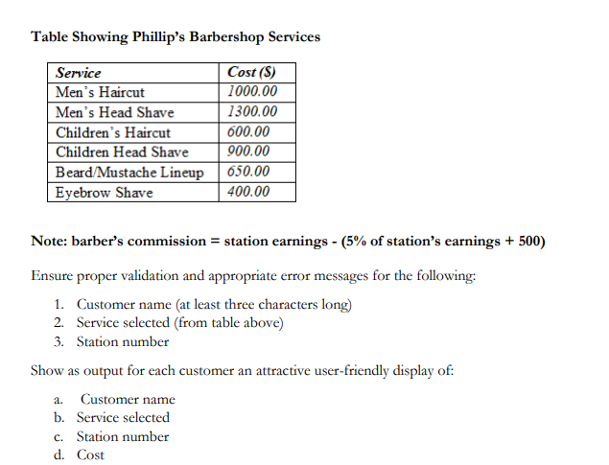

Once the system reaches 720 minutes (about 12 hours) it is assumed that the barbershop is closed for business. At this point display the following in a neatly formatted order:

1. Total sales per station for the day

2. Total customers per station for the day

3. Commission per station for the day (station's earnings - rent amount)

4. Total day’s sales

5. Total customers for the day

6. Total revenue for the day (commission plus total rent for the day)

IPO Chart Contribution:

Group members conducted a meeting during which they:

| Cameron, James | * Identified control structure, calculations and output for IPO Chart |
| --- | --- |
| Ellis, Chevannese | * Identified control structures, calculations and output for the IPO Chart |
| Myrie, Zachery | * Identified calculations |
| Tennant, Aaliyah | * Facilitated meeting * Functioned as a scribe * Identified input, control structure, calculations and output for IPO Chart |

**Pseudocode**

START

1. DECLARE Fname as STRING
2. DECLARE service as CHARACTER
3. DECLARE snum, minutes, cNum1, cNum2, cNum3, totC as INTEGER
4. DECLARE tot_station1, tot_station2, tot_station3, commission1, commission2, commission3, statEarn, rev, totCommission, rent, price as REAL
5. cNum1 = 0
6. cNum2 = 0
7. cNum3 = 0
8. For (minutes = 0 TO <= 720 STEP 30)
   1. PRINT “Please enter First Name (Enter ‘999’ to finish):”
   2. READ Fname
   3. IF Fname = “999” THEN
      1. BREAK
   4. WHILE length(Fname) <3
      1. PRINT “Invalid Name”
      2. PRINT “Enter customer first name: ”
      3. READ Fname
   5. ENDWHILE
   6. PRINT “ M = Men’s Haircut - $1000\n S = Men’s Head Shave - $1300\n C = Children’s Haircut - $600\n G = Children’s Head Shave - $900\n B = Beard/Mustache Lineup - $650\n E = Eyebrow Shave - $400”
   7. PRINT “Please enter the service (M, S, C, G, B, E): ”
   8. READ service
   9. WHILE service != ‘M’ AND service != ‘S’ AND service != ‘C’ AND service != ‘G’ AND service != ‘B’ AND service != ‘E’
      1. PRINT “Service not Offered”
      2. PRINT “Please enter service: ”
      3. READ service
   10. ENDWHILE
   11. DOCASE service
       1. CASE ‘M’
          1. price = 1000.00
       2. CASE ‘S’
          1. price = 1300.00
       3. CASE ‘C’
          1. price = 600.00
       4. CASE ‘G’
          1. price = 900.00
       5. CASE ‘B’
          1. price = 650.00
       6. CASE ‘E’
          1. price = 400.00
       7. CASE OTHER
          1. PRINT “Service not Offered”
   12. ENDCASE
   13. PRINT “Please enter the station number (1, 2, 3): ”
   14. READ snum
   15. WHILE snum < 1 OR snum > 3
       1. PRINT “Invalid Station. Please enter station Number (1, 2, 3): ”
       2. READ snum
   16. ENDWHILE
   17. DOCASE snum
       1. CASE 1
          1. tot_station1 = tot_station1 + price
          2. cNum1 = cNum1 + 1
          3. commission1 = tot_station1 - (0.05 * tot_station1 + 500)
       2. CASE 2
          1. tot_station2 = tot_station2 + price
          2. cNum2 = cNum2 + 1
          3. commission2 = tot_station2 - (0.05 * tot_station2 + 500)
       3. CASE 3
          1. tot_station3 = tot_station3 + price
          2. cNum3 = cNum3 + 1
          3. commission3 = tot_station3 - (0.05 * tot_station3 + 500)
       4. CASE OTHER
9. PRINT “Invalid Station. Please enter station Number (1, 2, 3): ”
   1. ENDCASE
   2. PRINT “Customer’s Receipt”
   3. PRINT “Customer’s Name: ”, Lname, Fname
   4. PRINT “Service Selected: ”, service
   5. IF service == ‘M’ THEN
      1. PRINT “Men’s Haircut”
   6. ELSE
      1. IF service == ‘S’
         1. PRINT “Men’s Head Shave”
      2. ELSE
         1. IF service == ‘C’
            1. PRINT “Children’s Haircut”
         2. ELSE
            1. IF service == ‘G’

PRINT “Children’s Head Shave”

* + - * 1. ELSE

IF service == ‘B’

PRINT “Beard/Mustache Lineup”

ELSE

IF service == ‘E’

PRINT “Eyebrow Shave”

ENDIF

ENDIF

ENDIF

ENDIF

ENDIF

ENDIF

* 1. PRINT “Station Number: ”, snum
  2. PRINT “Cost: $”, price

1. ENDFOR
2. statEarn = tot_station1 + tot_station2 + tot_station3
3. totC = cNum1 + cNum2 + cNum3
4. totCommission = commission1 + commission2 + commission3
5. rent = (0.05 * statEarn) + (500 * 3)
6. rev = totCommission+ rent
7. PRINT “Total sales per station for the day: ”
8. PRINT “Station 1 - $”, tot_station1
9. PRINT “Station 2 - $”, tot_station2
10. PRINT “Station 3 - $”, tot_station3
11. PRINT “Total customers per station for the day: ”
12. PRINT “Station 1: ” cNum1
13. PRINT “Station 2: ” cNum2
14. PRINT “Station 3: ” cNum3
15. PRINT “Commission for station 1 for the day: $”,commission1
16. PRINT “Commission for station 2 for the day: $”,commission2
17. PRINT “Commission for station 3 for the day: $”,commission3
18. PRINT “Total Day’s Sales: $”, statEarn
19. PRINT “Total customers for the day: ”, totC
20. PRINT “Revenue for the day: $”, rev

STOP

Pseudocode Contribution:

Group members conducted a meeting during which they:

| Cameron, James | * Identified control structure, calculations and output for Pseudocode |
| --- | --- |
| Ellis, Chevannese | * Identified additional control structure, calculations and output for the Pseudocode |
| Myrie, Zachery | * Calculations and output for Pseudocode |
| Tennant, Aaliyah | * Facilitated meeting * Functioned as a scribe * Identified control structure, calculations and output for Pseudocode |

Python Source Code

# Initialize variables

name = ""

service = ""

snum = 0

# Initialize station-specific variables

cNum1 = 0

cNum2 = 0

cNum3 = 0

tot_station1 = 0

tot_station2 = 0

tot_station3 = 0

# Initialize commission variables

commission1 = 0

commission2 = 0

commission3 = 0

# Initialize total day's metrics

statEarn = 0

totC = 0

totCommission = 0

rent = 0

rev = 0

price = 0

# Loop to simulate the barbershop's operation

for minutes in range(0, 721, 30):

# Input prompting

print("Please enter Customer's Name (Enter 'U' to finish):")

name = input()

# Check if the user wants to end the loop

if name == 'U':

break

while len(name) < 3:

print("Invalid Name")

print("Enter customer's name:")

name = input()

# Validate service input with while loop

while True:

print(" M = Men’s Haircut - $1000\n S = Men’s Head Shave - $1300\n C = Children’s Haircut - $600\n G = Children’s Head Shave - $900\n B = Beard/Mustache Lineup - $650\n E = Eyebrow Shave - $400")

print("Please enter the service (M, S, C, G, B, E): ")

service = input()

if service in ['M', 'S', 'C', 'G', 'B', 'E']:

break

else:

print("Service not Offered")

print("Please enter service:")

# Calculate price based on the service

match service:

case 'M':

price = 1000.00

case 'S':

price = 1300.00

case 'C':

price = 600.00

case 'G':

price = 900.00

case 'B':

price = 650.00

case 'E':

price = 400.00

# Validate snum input with while loop

while True:

print("Please enter the station number (1, 2, 3): ")

snum = int(input())

if 1 <= snum <= 3:

break

else:

print("Invalid Station. Please enter station Number (1, 2, 3): ")

# Update station-specific metrics

match snum:

case 1:

tot_station1 = tot_station1 + price

cNum1 = cNum1 + 1

commission1 = tot_station1 - (0.05 * tot_station1 + 500)

case 2:

tot_station2 = tot_station2 + price

cNum2 = cNum2 + 1

commission2 = tot_station2 - (0.05 * tot_station2 + 500)

case 3:

tot_station3 = tot_station3 + price

cNum3 = cNum3 + 1

commission3 = tot_station3 - (0.05 * tot_station3 + 500)

#Display Customer's Receipt

print("\nCustomer’s Receipt")

print("Customer’s Name: ", name)

print("Service Selected: ", service)

if service == 'M':

print("Men’s Haircut")

elif service == 'S':

print("Men’s Head Shave")

elif service == 'C':

print("Children’s Haircut")

elif service == 'G':

print("Children’s Head Shave")

elif service == 'B':

print("Beard/Mustache Lineup")

elif service == 'E':

print("Eyebrow Shave")

print("Station Number: ", snum)

print("Cost: $", price)

# Calculate total day's metrics

statEarn = tot_station1 + tot_station2 + tot_station3

totC = cNum1 + cNum2 + cNum3

# Calculate total revenue for the day

totCommission = commission1 + commission2 + commission3

rent = (0.05 * statEarn) + (500 * 3)

rev = totCommission + rent

# Display results

print("\nTotal Sales per Station for the Day:")

print("Station 1: $", tot_station1)

print("Station 2: $", tot_station2)

print("Station 3: $", tot_station3)

print("\nTotal Customers per Station for the Day:")

print("Station 1:", cNum1)

print("Station 2:", cNum2)

print("Station 3:", cNum3)

print("\nCommission per Station for the Day:")

print("Station 1: $", commission1)

print("Station 2: $", commission2)

print("Station 3: $", commission3)

print("\nTotal Day’s Sales: $", statEarn)

print("Total Customers for the Day:", totC)

print("Total Revenue for the Day: $", rev)

Python Source Code Screenshot

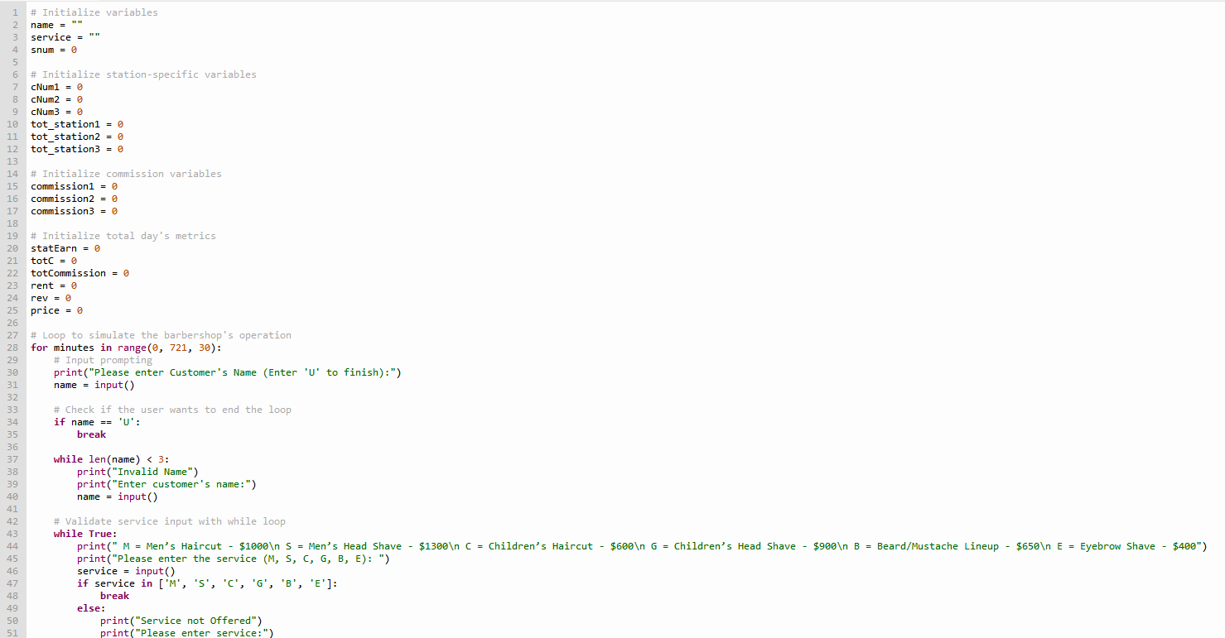

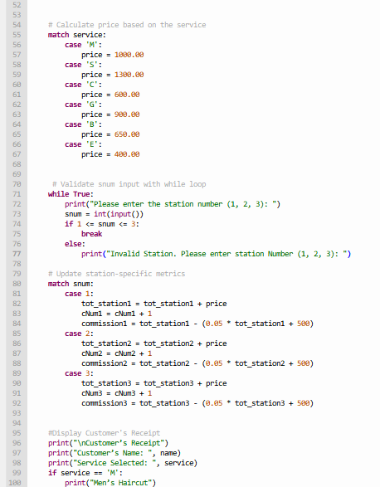

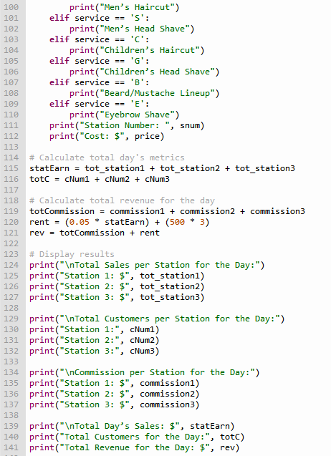

Python Test Data Output

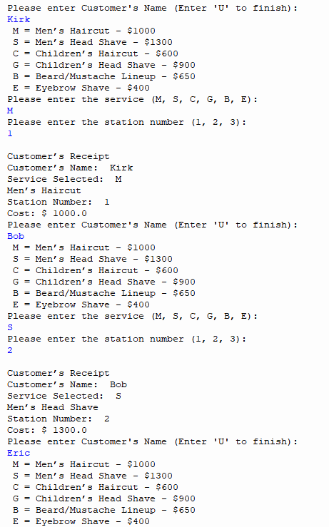

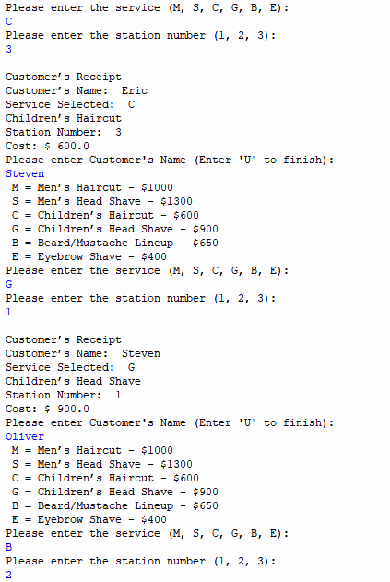

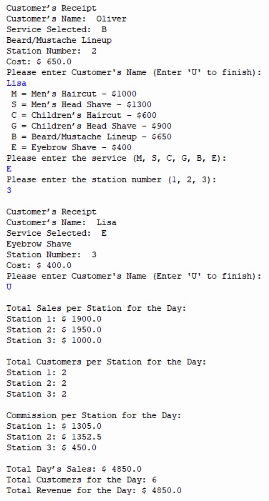

Aalia’s

**Python Source Code**

#Authors: Aaliyah Tennant and Zachery Myrie

#Date: 12/07/2023

#Programme: A digital system to help manage daily operations at a barber shop.

#DECLARATIONS:

#Variables

minutes = int

cNum1 = int

cNum2 = int

cNum3 = int

totC = int

tot_station1 = float

tot_station2 = float

tot_station3 = float

commission1 = float

commission2 = float

commission3 = float

statEarn = float

rev = float

totCommission = float

rent = float

price = float

#Constants

cNum1 = 0

cNum2 = 0

cNum3 = 0

minute = 0

totCommission = 0

commission1 = 0

commission2 = 0

commission3 = 0

tot_station1 = 0

tot_station2 = 0

tot_station3 = 0

#Loops until minutes = 720, adding 30 each time

for minutes in range(0, 720, 30):

Fname = (input("Please enter First Name (Enter '999' to finish): "))

#Checks if the user wants to end loop

if Fname == "999":

break

#Measures length of first name so its atleast 3 characters long

while len(Fname) < 3:

print ("Invalid Name")

Fname = str(input("Please enter First Name: "))

print (" M = Men’s Haircut - $1000\n S = Men’s Head Shave - $1300\n C = Children’s Haircut - $600 ")

print (" G = Children’s Head Shave - $900\n B = Beard/Mustache Lineup - $650\n E = Eyebrow Shave - $400")

service = str(input("Please enter the service (M, S, C, G, B, E): "))

while service != 'M' and service != 'S' and service != 'C' and service != 'G' and service != 'B' and service != 'E':

print ("Service not Offered")

service = str(input("Please enter service: "))

match service:

case 'M':

price = 1000.00

case 'S':

price = 1300.00

case 'C':

price = 600.00

case 'G':

price = 900.00

case 'B':

price = 650.00

case 'E':

price = 400.00

snum = int(input("Please enter the station number (1, 2, 3): "))

while snum < 1 or snum > 3:

print ("Invalid Station.")

snum = int(input("Please enter the station number (1, 2, 3): "))

match snum:

case 1:

tot_station1 = tot_station1 + price

cNum1 = cNum1 + 1

commission1 = tot_station1 - (0.05 * tot_station1 + 500)

case 2:

tot_station2 = tot_station2 + price

cNum2 = cNum2 + 1

commission2 = tot_station2 - (0.05 * tot_station2 + 500)

case 3:

tot_station3 = tot_station3 + price

cNum3 = cNum3 + 1

commission3 = tot_station3 - (0.05 * tot_station3 + 500)

print ("Customer’s Receipt ")

print("Customer Name: ", Fname)

print("Service Selected: ", service)

#Decides what to output according to the service chosen

if service == 'M':

print ("Men’s Head Shave")

else:

if service == 'S':

print("Men's Head Shave")

else:

if service == 'C':

print ("Children’s Haircut")

else:

if service == 'G':

print ("Children’s Head Shave")

else:

if service == 'B':

print ("Beard/Mustache Lineup")

else:

if service == 'E':

print ("Eyebrow Shave")

print ("Station Number: ", snum)

print ("Cost: $", round(price, 2))

#All station earnings

statEarn = tot_station1 + tot_station2 + tot_station3

#Total number of customers

totC = cNum1 + cNum2 + cNum3

#The sum of commissions

totCommission = commission1 + commission2 + commission3

#Rent amount

rent = (0.05 * statEarn) + (500 * 3)

rev = totCommission + rent

# Display results

print("Total Sales per Station for the Day:")

print("Station 1: $", tot_station1)

print("Station 2: $", tot_station2)

print("Station 3: $", tot_station3)

print("Total Customers per Station for the Day:")

print("Station 1:", cNum1)

print("Station 2:", cNum2)

print("Station 3:", cNum3)

print("Commission per Station for the Day:")

print("Station 1: $", commission1)

print("Station 2: $", commission2)

print("Station 3: $", commission3)

print("Total Day’s Sales: $", statEarn)

print("Total Customers for the Day:", totC)

print("Total Revenue for the Day: $", rev)

**Python Source Code Output**

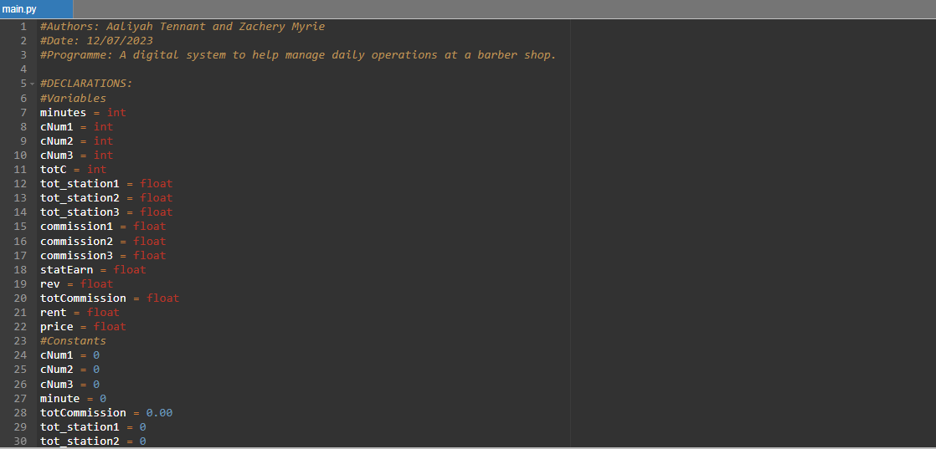

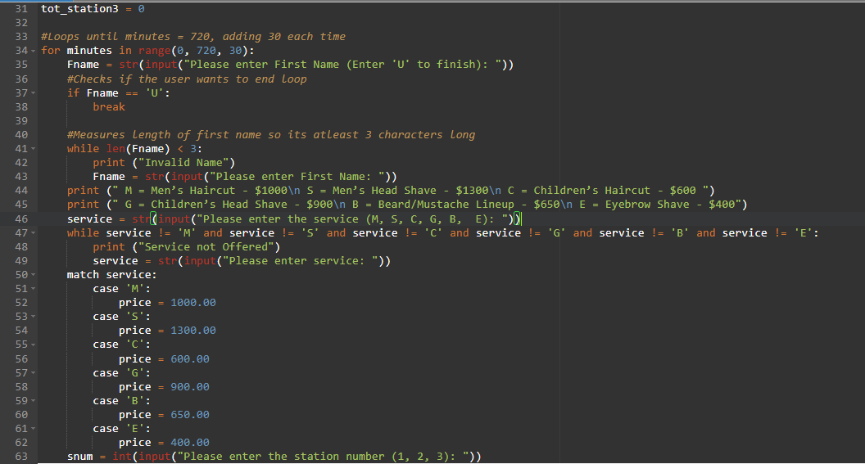

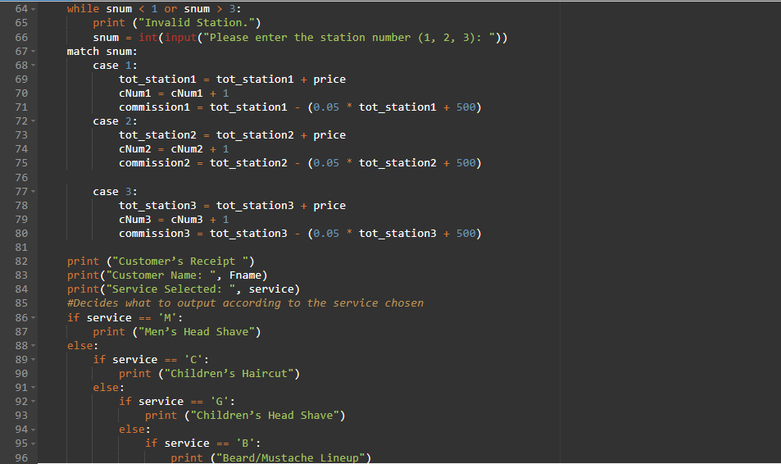

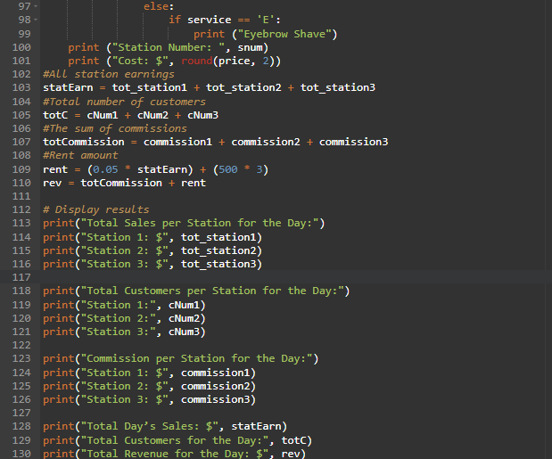

**Test Data Output**

